1. What is the difference between traditional Firewall and NGFW in-terms of Application based filtering.

Traditional Firewalls operate at L3 and L4 and are divided into two types, stateless firewalls and stateful firewalls

Stateless Firewalls filter traffic based on IP & Port numbers, they are not aware of the session state.

While Stateful Firewalls filter traffic based on IP & Port numbers in addition to that they are aware of the session state and maintain a Session/State Table which is dynamic in nature.

Both types of traditional firewalls do not have the ability to perform application based filtering nor do they operate at L5.

Next Generation Firewalls (NGFWs) operate from L3-L7 it performs all the functions of Proxy/Application Intelligence Firewall, Unified Threat Management (UTM) Firewall, NAT Firewall in addition to them it has application awareness and control, User identity awareness, QoS management etc..

Proxy/Application Intelligence Firewall checks both the Header and Data, after receiving traffic from the source it decrypts the data, checks the data and re-encrypts the data and forwards the packet to the actual destination device inside its network.

The server/destination device sends its response to the proxy firewall (and assumes it as the client) then proxy checks the packet and forwards it to the client or source device.

It is able to do this by acting as a proxy on behalf of both the client and server and exchanging the keys with them, using these keys it decrypts and encrypts traffic.

Unified Threat Management (UTM) Firewall Uses signatures provided by vendors to identify malware.

NAT Firewall is responsible for NAT based on ACL

Using Application Awareness and control NGFWs can identify, allow, block, or restrict specific applications, regardless of port, protocol, or IP address, by inspecting traffic at L7

User awareness is the ability to identify users and groups with the help of directory services like AD and enforce security policies.

Quality of Service (QoS) management is about prioritising certain traffic based on the policies, for example prioritizing VoIP over emails etc..

2. Create an application group of any 5 Applications of your choice and write a Security policy to allow only those applications.

Application Group to allow basic apps
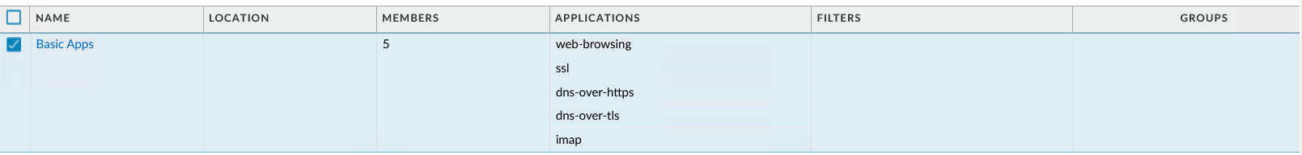

Security policy to allow only those applications.
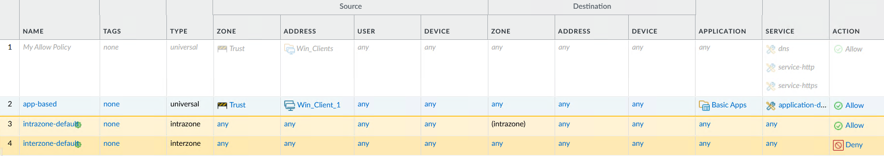

3. Change all your port based rules to application based filtering rules.

